**Blockchain Based Crime Evidence System**

**Abstract:**

In traditional crime evidence management systems, all data is stored on centralized servers that are vulnerable to tampering by administrators or malicious actors, compromising the integrity of criminal investigations. To address this critical issue, the proposed system employs blockchain technology to securely manage and store crime evidence details in a decentralized and tamper-proof manner. By leveraging Ethereum-based blockchain and smart contracts written in Solidity, the system ensures that every piece of evidence is stored as an immutable transaction linked by cryptographic hashes. Any attempt to alter data is immediately detected through hash mismatches, preserving the authenticity of records.The system features role-based access with separate modules for administrators and officers, enabling secure addition and retrieval of evidence data via a Django web interface. Admins can register officers and monitor all recorded cases, while officers can upload and access evidence directly into the blockchain. The use of smart contracts provides programmable control over data operations, and detailed logs such as transaction IDs and block numbers ensure transparency. This approach offers a robust, secure, and traceable platform for crime evidence handling, significantly enhancing the reliability and integrity of criminal justice procedures.

**Introduction:**

Crime investigation and evidence management systems are critical components of law enforcement. However, traditional systems rely heavily on centralized databases, which are vulnerable to data tampering, unauthorized access, and lack transparency. Altering crime evidence records can lead to wrongful acquittals or convictions, undermining the justice system.

To address these vulnerabilities, this project proposes a **Blockchain Based Crime Evidence System**. By leveraging the decentralized and tamper-proof architecture of blockchain technology, this system ensures that crime evidence is stored securely and immutably across distributed nodes. Each evidence entry is treated as a block containing a unique hash, and any attempt to alter the data would disrupt the hash chain, thereby making tampering detectable and preventable.

The system employs **Ethereum blockchain** and **smart contracts** written in **Solidity** to store, retrieve, and manage evidence data. Smart contracts provide programmable, transparent, and verifiable logic for data interaction, ensuring evidence integrity throughout its lifecycle.

Key users of the system include:

* **Admin (Police Department)**: Responsible for registering officers and monitoring the system.
* **Officers**: Authorized personnel who can add and retrieve crime evidence.

The platform also integrates a user-friendly interface supported by a Python backend, allowing users to interact with the blockchain seamlessly. Real-time logs including block numbers, transaction hashes, and status updates ensure transparency and accountability for each action taken within the system.

This project demonstrates a secure, decentralized, and transparent approach to evidence management using blockchain, significantly enhancing the integrity and trust in the criminal justice process.

**Literature Survey:**

**1. Limitations of Centralized Evidence Systems**

Traditional crime evidence management relies on centralized databases that are vulnerable to tampering by administrators. There's no integrated mechanism to detect unauthorized changes, compromising the integrity of legal investigations.

**2. Tamper-Proof Storage with Blockchain**

Blockchain offers a decentralized and tamper-resistant architecture. Each data block is linked via unique hash codes, and any unauthorized modification results in hash mismatches, making tampering easily detectable and enhancing data integrity.

**3. Use of Smart Contracts for Data Operations**

Smart contracts (developed in Solidity) are employed to handle operations such as adding and retrieving crime evidence. These contracts provide secure, automated, and transparent interaction with the blockchain, ensuring that only authorized functions are executed.

**4. Role-Based Access and Modules**

The system features distinct modules for **Admin** and **Officer** roles. Admins manage officer credentials and view all evidence, while officers can log in, record, and access crime evidence relevant to their jurisdiction. This modular design enhances accountability and traceability.

**5. Technical Implementation Using Ethereum and Python**

The system uses a private Ethereum blockchain setup integrated with a Python backend. Deployment involves running blockchain scripts, deploying smart contracts, and interfacing via a web portal. This practical implementation demonstrates the feasibility of blockchain in real-world crime data management.

**Existing System:**

In the existing crime evidence management systems, all crime and evidence records are stored in a centralized database maintained by the police department. This centralization poses a major risk, as the database can be tampered with by administrators or unauthorized users without detection. Since evidence is a crucial component in identifying and prosecuting the correct suspect, any alteration of these records can lead to false outcomes in legal proceedings. Furthermore, there is no dedicated mechanism or tool available in the current system to detect if data has been modified, which raises serious concerns about data integrity, transparency, and accountability.

In the traditional crime evidence management system, all crime and evidence-related data is stored on a single centralized server. This centralized structure presents several vulnerabilities:

1. **Tampering Risk**: The data stored on such a centralized database can be easily altered by individuals with administrative access. There are no built-in mechanisms to detect such unauthorized modifications.
2. **Integrity Issues**: Since crime evidence is crucial for legal proceedings and identifying culprits, any alteration can lead to wrongful acquittals or convictions.
3. **Lack of Transparency**: The system does not provide verifiable trails for when or how evidence was stored or accessed, making it difficult to ensure data authenticity.
4. **No Detection Tools**: There are no automated tools available in the current system to identify or flag unauthorized data alterations.

This vulnerability can compromise entire investigations, making it imperative to shift toward a more secure and verifiable system.

**Disadvantages of Existing Systems:**

|  |  |
| --- | --- |
|  |  |

1. **Centralized Storage**

All crime and evidence records are stored in a single central server.

Single point of failure and easy to compromise.

1. **Tampering Possibility**

Database administrators can alter or delete evidence without detection.

No built-in mechanism to detect unauthorized changes.

1. **No Data Integrity Verification**

Current systems do not verify the authenticity of stored evidence.

This can lead to the wrongful release of criminals or failed convictions.

**Proposed System:**

The proposed system introduces a blockchain-based approach for managing crime evidence to overcome the limitations of the centralized model. Using Ethereum blockchain and smart contracts developed in Solidity, the system ensures that all evidence records are stored in a decentralized, tamper-proof ledger. Each transaction (evidence entry) is saved in blocks with unique hash values, making unauthorized changes easily detectable through hash mismatches. The system offers role-based access for administrators and officers via a Django web interface, enabling secure data operations like adding officers and uploading evidence. By providing immutable, verifiable records with full traceability, this blockchain-based system significantly enhances security, data integrity, and trust in criminal investigations.

Key benefits include:

* **Decentralized Storage**: Evidence data is not stored on a single server but across multiple nodes, reducing the risk of data loss or manipulation.
* **Immutability**: Each data entry (block) is linked with a unique hash and timestamp. Any unauthorized change will alter the hash, making tampering detectable.
* **Audit Trail**: All operations—such as adding or retrieving evidence—are recorded in blocks with full transparency and traceability.
* **Smart Contracts**: Evidence can be securely recorded and accessed via smart contracts written in Solidity. These contracts define specific functions to manage evidence, and interactions with them are logged permanently on the blockchain.
* **Role-Based Access**: Admins and officers have defined roles. Admins manage officer accounts and monitor evidence submissions, while officers submit and retrieve crime data.

**Advantages of the Proposed System:**

**🔐 Tamper-Proof & Immutable**

* Once evidence is added to the blockchain, it **cannot be changed or deleted**.
* Any tampering attempt is **immediately detected** through hash mismatches.

**🧩 Decentralized Storage**

* Data is stored across multiple nodes, **eliminating a single point of failure**.
* More secure and **resilient to attacks**.

**🛠 Smart Contracts Integration**

* Evidence management is automated using smart contracts (written in **Solidity**).
* Ensures **only authorized actions** are executed and logged transparently.

**System Analysis:**

**1. Introduction**

Traditional crime evidence management systems rely on centralized databases, which are vulnerable to tampering by administrators. To address this, the proposed system utilizes **Blockchain technology** to store and manage crime evidence in a decentralized, secure, and tamper-proof manner.

**2. Problem Statement**

* **Centralization Vulnerability**: All data stored in one location can be manipulated.
* **Lack of Tamper Detection**: No mechanism exists to detect unauthorized changes to the data.
* **Data Integrity Issues**: Altered evidence can result in false justice outcomes.

**3. Proposed Solution**

* **Blockchain Integration**: Crime evidence is stored as blocks, ensuring data immutability and traceability.
* **Smart Contracts**: Used to add, retrieve, and manage data securely via functions written in Solidity.
* **Ethereum Deployment**: The smart contract is deployed using an Ethereum test environment for demo purposes.

**4. System Architecture**

* **Frontend**: HTML interface accessed via http://127.0.0.1:8000/index.html
* **Backend**: Python server interfacing with Ethereum Blockchain
* **Blockchain Layer**: Ethereum network using Truffle for smart contract deployment and Ganache for local blockchain simulation

**5. Modules and Features**

**Admin Panel**

* **Admin Login**: Default credentials (admin/admin)
* **Add Officer Details**: Officer and police station data is added to the blockchain.
* **View Officers**: Displays all registered officers.
* **View Evidences**: Allows admin to see all uploaded crime and evidence records.

**Officer Panel**

* **Officer Login**: Officers login with credentials issued by the admin.
* **Add New Evidences**: Officers input evidence details and upload images; data gets stored in the blockchain.
* **Access Evidences**: Officers retrieve details by evidence ID for reference or follow-up.

**6. Screenshots-Based Workflow**

1. **Start Python Server**: run.bat starts the backend.
2. **Deploy Smart Contract**:
   * Navigate to hello-eth/node-modules/bin
   * Run runBlockchain.bat and deploy using the migrate command
3. **Admin Login & Officer Management**:
   * Add new officers and assign login credentials
4. **Officer Evidence Upload**:
   * Officers upload detailed evidence including images
   * Blockchain logs data with metadata like block number, transaction ID, and hash
5. **View & Verify Evidence**:
   * Officers can retrieve tamper-proof evidence using unique IDs

**7. Benefits of Blockchain Use**

* **Data Integrity**: Tamper-proof records validated by hash comparison
* **Transparency**: Each transaction is recorded and visible with logs
* **Security**: No single point of failure due to decentralization
* **Auditability**: Full traceability of data entries and modifications

**SYSTEM REQUIREMENTS:**

**HARDWARE REQUIREMENTS:**

• System : Pentium IV 2.4 GHz.

• Hard Disk : 40 GB.

• Ram : 512 Mb.

**SOFTWARE REQUIREMENTS:**

• Operating system : - Windows.

• Coding Language : python.

**System Architecture**

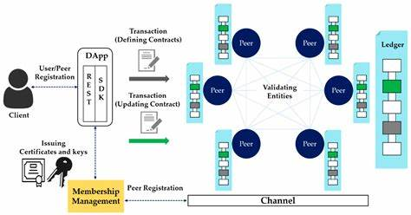

**UML Diagrams:**

**Class diagram**

The class diagram is used to refine the use case diagram and define a detailed design of the system. The class diagram classifies the actors defined in the use case diagram into a set of interrelated classes. The relationship or association between the classes can be either an "is-a" or "has-a" relationship. Each class in the class diagram was capable of providing certain functionalities. These functionalities provided by the class are termed "methods" of the class. Apart from this, each class may have certain "attributes" that uniquely identify the class.

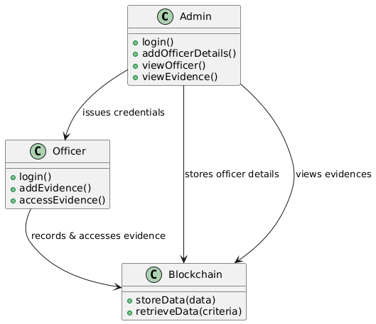

Figure-5.1: Class Diagram

**Sequence Diagram**

A sequence diagram in Unified Modeling Language (UML) is a kind of interaction diagram that shows how processes operate with one another and in what order. It is a construct of a Message Sequence Chart. A sequence diagram shows, as parallel vertical lines (“lifelines”), different processes or objects that live simultaneously, and as horizontal arrows, the messages exchanged between them, in the order in which they occur. This allows the specification of simple runtime scenarios in a graphical manner.

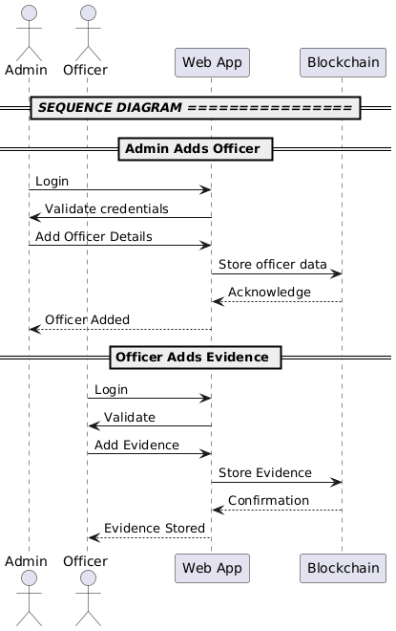

Figure-5.2: Sequence Diagram

**Activity diagram**

Activity diagrams are graphical representations of Workflows of stepwise activities and actions with support for choice, iteration, and concurrency. In the Unified Modeling Language, activity diagrams can be used to describe the business and operational step-by-step workflows of components in a system. An activity diagram shows the overall flow of control.

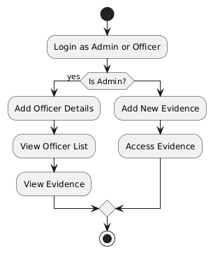

Figure-5.3: Activity Diagram

**Data flow diagram**

A data flow diagram (DFD) is a graphical representation of how data moves within an information system. It is a modeling technique used in system analysis and design to illustrate the flow of data between various processes, data stores, data sources, and data destinations within a system or between systems. Data flow diagrams are often used to depict the structure and behavior of a system, emphasizing the flow of data and the transformations it undergoes as it moves through the system.

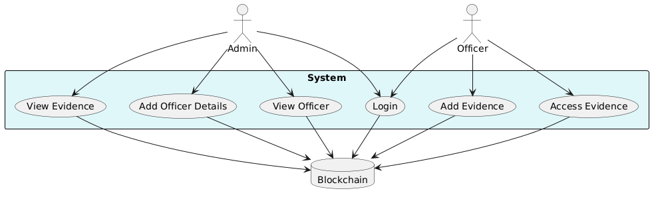

Figure-5.4: Dataflow Diagram

**Component diagram:** Component diagram describes the organization and wiring of the physical components in a system.

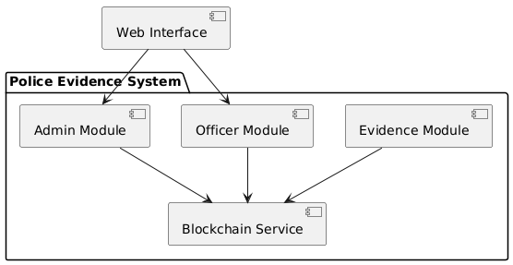

Figure-5.5: Component Diagram

**Use Case diagram:** A use case diagram in the Unified Modeling Language (UML) is a type of behavioral diagram defined by and created from a Use-case analysis. Its purpose is to present a graphical overview of the functionality provided by a system in terms of actors, their goals (represented as use cases), and any dependencies between those use cases. The main purpose of a use case diagram is to show what system functions are performed for which actor. Roles of the actors in the system can be depicted.

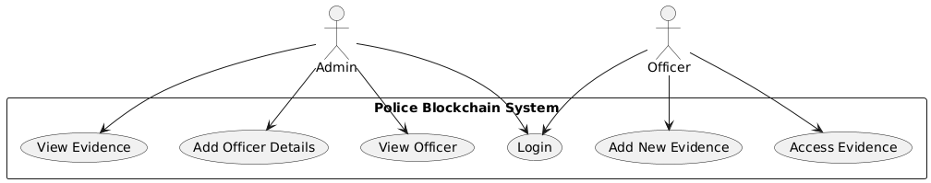

Figure-5.6: Use Case Diagram

**Deployment Diagram:**

A deployment diagram in UML illustrates the physical arrangement of hardware and software components in the system. It visualizes how different software artifacts, such as data processing scripts and model training components, are deployed across hardware nodes and interact with each other, providing insight into the system’s infrastructure and deployment strategy.

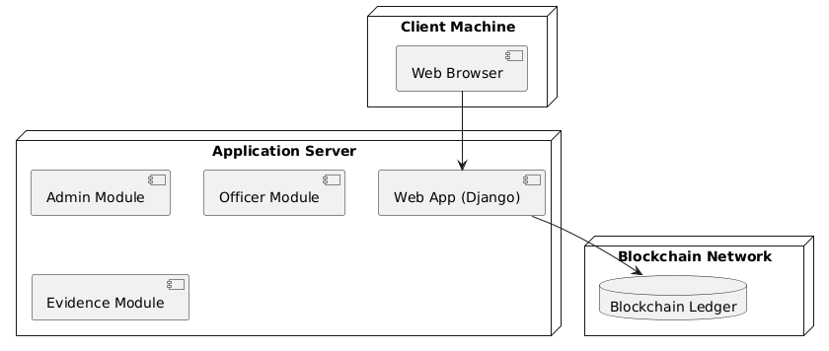

Figure-5.7: DeploymentDiagram

**System Implementations:**

**System Modules**

1. **Admin Login**
   * Default credentials: admin/admin.
   * Access to manage officers and view evidences.
2. **Add Officer Details**
   * Admin adds officers and their police station info.
   * Officer credentials are issued for login.
3. **View Officer**
   * Displays list of registered officers and their locations.
4. **View Evidence**
   * Admin can view evidence/crime details submitted by officers.
5. **Officer Login**
   * Officers log in using credentials provided by admin.
6. **Add New Evidences**
   * Officers record new crime evidence with image upload.
   * Data is securely saved to Blockchain.
7. **Access Evidences**
   * Officers can retrieve and view evidence from the Blockchain by ID.

**System Environment:**

# What is Python :-

Below are some facts about Python.

Python is currently the most widely used multi-purpose, high-level programming language.

Python allows programming in Object-Oriented and Procedural paradigms. Python programs generally are smaller than other programming languages like Java.

Programmers have to type relatively less and indentation requirement of the language, makes them readable all the time.

Python language is being used by almost all tech-giant companies like – Google, Amazon, Facebook, Instagram, Dropbox, Uber… etc.

The biggest strength of Python is huge collection of standard library which can be used for the following .

* + [Machine Learning](https://www.geeksforgeeks.org/machine-learning/)
  + GUI Applications (like Kivy, Tkinter, PyQt etc. )
  + Web frameworks like Django (used by YouTube, Instagram, Dropbox)
  + Image processing (like Opencv, Pillow)
  + Web scraping (like Scrapy, BeautifulSoup, Selenium)
  + Test frameworks
  + Multimedia

### **Advantages of Python :-**

Let’s see how Python dominates over other languages.

#### 1. Extensive Libraries

Python downloads with an extensive library and it contain code for various purposes like regular expressions, documentation-generation, unit-testing, web browsers, threading, databases, CGI, email, image manipulation, and more. So, we don’t have to write the complete code for that manually.

#### 2. Extensible

As we have seen earlier, Python can be**extended to other languages**. You can write some of your code in languages like C++ or C. This comes in handy, especially in projects.

#### 3. Embeddable

Complimentary to extensibility, Python is embeddable as well. You can put your Python code in your source code of a different language, like C++. This lets us add **scripting capabilities**to our code in the other language.

#### 4. Improved Productivity

The language’s simplicity and extensive libraries render programmers**more productive** than languages like Java and C++ do. Also, the fact that you need to write less and get more things done.

#### 5. IOT Opportunities

Since Python forms the basis of new platforms like Raspberry Pi, it finds the future bright for the Internet Of Things. This is a way to connect the language with the real world.

#### 6. Simple and Easy

When working with Java, you may have to create a class to print **‘Hello World’**. But in Python, just a print statement will do. It is also quite **easy to learn, understand,** and**code.** This is why when people pick up Python, they have a hard time adjusting to other more verbose languages like Java.

#### 7. Readable

Because it is not such a verbose language, reading Python is much like reading English. This is the reason why it is so easy to learn, understand, and code. It also does not need curly braces to define blocks, and **indentation is mandatory.** This further aids the readability of the code.

#### 8. Object-Oriented

This language supports both the **procedural and object-oriented**programming paradigms. While functions help us with code reusability, classes and objects let us model the real world. A class allows the **encapsulation of data** and functions into one.

#### 9. Free and Open-Source

Like we said earlier, Python is **freely available.** But not only can you[**download Python**](https://data-flair.training/blogs/install-python-windows/) for free, but you can also download its source code, make changes to it, and even distribute it. It downloads with an extensive collection of libraries to help you with your tasks.

#### 10. Portable

When you code your project in a language like C++, you may need to make some changes to it if you want to run it on another platform. But it isn’t the same with Python. Here, you need to**code only once**, and you can run it anywhere. This is called **Write Once Run Anywhere (WORA)**. However, you need to be careful enough not to include any system-dependent features.

#### 11. Interpreted

Lastly, we will say that it is an interpreted language. Since statements are executed one by one, **debugging is easier** than in compiled languages.

Any doubts till now in the advantages of Python? Mention in the comment section.

### **Advantages of Python Over Other Languages**

#### 1. Less Coding

Almost all of the tasks done in Python requires less coding when the same task is done in other languages. Python also has an awesome standard library support, so you don’t have to search for any third-party libraries to get your job done. This is the reason that many people suggest learning Python to beginners.

#### 2. Affordable

Python is free therefore individuals, small companies or big organizations can leverage the free available resources to build applications. Python is popular and widely used so it gives you better community support.

**The 2019 Github annual survey showed us that Python has overtaken Java in the most popular programming language category.**

#### 3. Python is for Everyone

Python code can run on any machine whether it is Linux, Mac or Windows. Programmers need to learn different languages for different jobs but with Python, you can professionally build web apps, perform data analysis and [**machine learning**](https://data-flair.training/blogs/machine-learning-tutorials-home/), automate things, do web scraping and also build games and powerful visualizations. It is an all-rounder programming language.

### **Disadvantages of Python**

So far, we’ve seen why Python is a great choice for your project. But if you choose it, you should be aware of its consequences as well. Let’s now see the downsides of choosing Python over another language.

#### 1. Speed Limitations

We have seen that Python code is executed line by line. But since [Python](https://www.python.org/) is interpreted, it often results in **slow execution**. This, however, isn’t a problem unless speed is a focal point for the project. In other words, unless high speed is a requirement, the benefits offered by Python are enough to distract us from its speed limitations.

#### 2. Weak in Mobile Computing and Browsers

While it serves as an excellent server-side language, Python is much rarely seen on the **client-side**. Besides that, it is rarely ever used to implement smartphone-based applications. One such application is called **Carbonnelle**.

The reason it is not so famous despite the existence of Brython is that it isn’t that secure.

#### 3. Design Restrictions

As you know, Python is **dynamically-typed**. This means that you don’t need to declare the type of variable while writing the code. It uses **duck-typing**. But wait, what’s that? Well, it just means that if it looks like a duck, it must be a duck. While this is easy on the programmers during coding, it can**raise run-time errors**.

#### 4. Underdeveloped Database Access Layers

Compared to more widely used technologies like **JDBC (Java DataBase Connectivity)** and **ODBC (Open DataBase Connectivity)**, Python’s database access layers are a bit underdeveloped. Consequently, it is less often applied in huge enterprises.

#### 5. Simple

No, we’re not kidding. Python’s simplicity can indeed be a problem. Take my example. I don’t do Java, I’m more of a Python person. To me, its syntax is so simple that the verbosity of Java code seems unnecessary.

This was all about the Advantages and Disadvantages of Python Programming Language.

**History of Python : -**

What do the alphabet and the programming language Python have in common? Right, both start with ABC. If we are talking about ABC in the Python context, it's clear that the programming language ABC is meant. ABC is a general-purpose programming language and programming environment, which had been developed in the Netherlands, Amsterdam, at the CWI (Centrum Wiskunde &Informatica). The greatest achievement of ABC was to influence the design of Python.Python was conceptualized in the late 1980s. Guido van Rossum worked that time in a project at the CWI, called Amoeba, a distributed operating system. In an interview with Bill Venners1, Guido van Rossum said: "In the early 1980s, I worked as an implementer on a team building a language called ABC at Centrum voor Wiskunde en Informatica (CWI).

I don't know how well people know ABC's influence on Python. I try to mention ABC's influence because I'm indebted to everything I learned during that project and to the people who worked on it."Later on in the same Interview, Guido van Rossum continued: "I remembered all my experience and some of my frustration with ABC. I decided to try to design a simple scripting language that possessed some of ABC's better properties, but without its problems. So I started typing. I created a simple virtual machine, a simple parser, and a simple runtime. I made my own version of the various ABC parts that I liked. I created a basic syntax, used indentation for statement grouping instead of curly braces or begin-end blocks, and developed a small number of powerful data types: a hash table (or dictionary, as we call it), a list, strings, and numbers."

**What is Machine Learning : -**

Before we take a look at the details of various machine learning methods, let's start by looking at what machine learning is, and what it isn't. Machine learning is often categorized as a subfield of artificial intelligence, but I find that categorization can often be misleading at first brush. The study of machine learning certainly arose from research in this context, but in the data science application of machine learning methods, it's more helpful to think of machine learning as a means of building models of data.

Fundamentally, machine learning involves building mathematical models to help understand data. "Learning" enters the fray when we give these models tunable parameters that can be adapted to observed data; in this way the program can be considered to be "learning" from the data.

Once these models have been fit to previously seen data, they can be used to predict and understand aspects of newly observed data. I'll leave to the reader the more philosophical digression regarding the extent to which this type of mathematical, model-based "learning" is similar to the "learning" exhibited by the human brain.Understanding the problem setting in machine learning is essential to using these tools effectively, and so we will start with some broad categorizations of the types of approaches we'll discuss here.

**Categories Of Machine Leaning :-**

At the most fundamental level, machine learning can be categorized into two main types: supervised learning and unsupervised learning.

Supervised learning involves somehow modeling the relationship between measured features of data and some label associated with the data; once this model is determined, it can be used to apply labels to new, unknown data. This is further subdivided into classification tasks and regression tasks: in classification, the labels are discrete categories, while in regression, the labels are continuous quantities. We will see examples of both types of supervised learning in the following section.

Unsupervised learning involves modeling the features of a dataset without reference to any label, and is often described as "letting the dataset speak for itself." These models include tasks such as clustering and dimensionality reduction.

Clustering algorithms identify distinct groups of data, while dimensionality reduction algorithms search for more succinct representations of the data. We will see examples of both types of unsupervised learning in the following section.

## Need for Machine Learning

Human beings, at this moment, are the most intelligent and advanced species on earth because they can think, evaluate and solve complex problems. On the other side, AI is still in its initial stage and haven’t surpassed human intelligence in many aspects. Then the question is that what is the need to make machine learn? The most suitable reason for doing this is, “to make decisions, based on data, with efficiency and scale”.

Lately, organizations are investing heavily in newer technologies like Artificial Intelligence, Machine Learning and Deep Learning to get the key information from data to perform several real-world tasks and solve problems. We can call it data-driven decisions taken by machines, particularly to automate the process. These data-driven decisions can be used, instead of using programing logic, in the problems that cannot be programmed inherently. The fact is that we can’t do without human intelligence, but other aspect is that we all need to solve real-world problems with efficiency at a huge scale. That is why the need for machine learning arises.

## Challenges in Machines Learning :-

While Machine Learning is rapidly evolving, making significant strides with cybersecurity and autonomous cars, this segment of AI as whole still has a long way to go. The reason behind is that ML has not been able to overcome number of challenges. The challenges that ML is facing currently are −

**Quality of data** − Having good-quality data for ML algorithms is one of the biggest challenges. Use of low-quality data leads to the problems related to data preprocessing and feature extraction.

**Time-Consuming task** − Another challenge faced by ML models is the consumption of time especially for data acquisition, feature extraction and retrieval.

**Lack of specialist persons** − As ML technology is still in its infancy stage, availability of expert resources is a tough job.

**No clear objective for formulating business problems** − Having no clear objective and well-defined goal for business problems is another key challenge for ML because this technology is not that mature yet.

**Issue of overfitting & underfitting** − If the model is overfitting or underfitting, it cannot be represented well for the problem.

**Curse of dimensionality** − Another challenge ML model faces is too many features of data points. This can be a real hindrance.

**Difficulty in deployment** − Complexity of the ML model makes it quite difficult to be deployed in real life.

## Applications of Machines Learning :-

Machine Learning is the most rapidly growing technology and according to researchers we are in the golden year of AI and ML. It is used to solve many real-world complex problems which cannot be solved with traditional approach. Following are some real-world applications of ML −

* Emotion analysis
* Sentiment analysis
* Error detection and prevention
* Weather forecasting and prediction
* Stock market analysis and forecasting
* Speech synthesis
* Speech recognition
* Customer segmentation
* Object recognition
* Fraud detection
* Fraud prevention
* Recommendation of products to customer in online shopping

# How to Start Learning Machine Learning?

Arthur Samuel coined the term **“Machine Learning”** in 1959 and defined it as a **“Field of study that gives computers the capability to learn without being explicitly programmed”.**

And that was the beginning of Machine Learning! In modern times, Machine Learning is one of the most popular (if not the most!) career choices. According to [Indeed](http://blog.indeed.com/2019/03/14/best-jobs-2019/), Machine Learning Engineer Is The Best Job of 2019 with a 344% growth and an average base salary of **$146,085** per year.

But there is still a lot of doubt about what exactly is Machine Learning and how to start learning it? So this article deals with the Basics of Machine Learning and also the path you can follow to eventually become a full-fledged Machine Learning Engineer. Now let’s get started!!!

### **How to start learning ML?**

This is a rough roadmap you can follow on your way to becoming an insanely talented Machine Learning Engineer. Of course, you can always modify the steps according to your needs to reach your desired end-goal!

### Step 1 – Understand the Prerequisites

In case you are a genius, you could start ML directly but normally, there are some prerequisites that you need to know which include Linear Algebra, Multivariate Calculus, Statistics, and Python. And if you don’t know these, never fear! You don’t need a Ph.D. degree in these topics to get started but you do need a basic understanding.

#### (a) Learn Linear Algebra and Multivariate Calculus

Both Linear Algebra and Multivariate Calculus are important in Machine Learning. However, the extent to which you need them depends on your role as a data scientist. If you are more focused on application heavy machine learning, then you will not be that heavily focused on maths as there are many common libraries available. But if you want to focus on R&D in Machine Learning, then mastery of Linear Algebra and Multivariate Calculus is very important as you will have to implement many ML algorithms from scratch.

#### (b) Learn Statistics

Data plays a huge role in Machine Learning. In fact, around 80% of your time as an ML expert will be spent collecting and cleaning data. And statistics is a field that handles the collection, analysis, and presentation of data. So it is no surprise that you need to learn it!!!  
Some of the key concepts in statistics that are important are Statistical Significance, Probability Distributions, Hypothesis Testing, Regression, etc. Also, Bayesian Thinking is also a very important part of ML which deals with various concepts like Conditional Probability, Priors, and Posteriors, Maximum Likelihood, etc.

#### (c) Learn Python

Some people prefer to skip Linear Algebra, Multivariate Calculus and Statistics and learn them as they go along with trial and error. But the one thing that you absolutely cannot skip is [Python](https://www.geeksforgeeks.org/python-programming-language/)! While there are other languages you can use for Machine Learning like R, Scala, etc. Python is currently the most popular language for ML. In fact, there are many Python libraries that are specifically useful for Artificial Intelligence and Machine Learning such as [Keras](https://keras.io/), [TensorFlow](https://www.tensorflow.org/), [Scikit-learn](https://scikit-learn.org/stable/), etc.

So if you want to learn ML, it’s best if you learn Python! You can do that using various online resources and courses such as [**Fork Python**](https://practice.geeksforgeeks.org/courses/fork-python) available Free on GeeksforGeeks.

### **Step 2 – Learn Various ML Concepts**

Now that you are done with the prerequisites, you can move on to actually learning ML (Which is the fun part!!!) It’s best to start with the basics and then move on to the more complicated stuff. Some of the basic concepts in ML are:

#### (a) Terminologies of Machine Learning

* **Model –**A model is a specific representation learned from data by applying some machine learning algorithm. A model is also called a hypothesis.
* **Feature –**A feature is an individual measurable property of the data. A set of numeric features can be conveniently described by a feature vector. Feature vectors are fed as input to the model. For example, in order to predict a fruit, there may be features like color, smell, taste, etc.
* **Target (Label) –**A target variable or label is the value to be predicted by our model. For the fruit example discussed in the feature section, the label with each set of input would be the name of the fruit like apple, orange, banana, etc.
* **Training –**The idea is to give a set of inputs(features) and it’s expected outputs(labels), so after training, we will have a model (hypothesis) that will then map new data to one of the categories trained on.
* **Prediction –**Once our model is ready, it can be fed a set of inputs to which it will provide a predicted output(label).

#### (b) Types of Machine Learning

* **Supervised Learning –**This involves learning from a training dataset with labeled data using classification and regression models. This learning process continues until the required level of performance is achieved.
* **Unsupervised Learning –**This involves using unlabelled data and then finding the underlying structure in the data in order to learn more and more about the data itself using factor and cluster analysis models.
* **Semi-supervised Learning –**This involves using unlabelled data like Unsupervised Learning with a small amount of labeled data. Using labeled data vastly increases the learning accuracy and is also more cost-effective than Supervised Learning.
* **Reinforcement Learning –**This involves learning optimal actions through trial and error. So the next action is decided by learning behaviors that are based on the current state and that will maximize the reward in the future.

### **Advantages of Machine learning :-**

#### 1. Easily identifies trends and patterns -

Machine Learning can review large volumes of data and discover specific trends and patterns that would not be apparent to humans. For instance, for an e-commerce website like Amazon, it serves to understand the browsing behaviors and purchase histories of its users to help cater to the right products, deals, and reminders relevant to them. It uses the results to reveal relevant advertisements to them.

#### 2. No human intervention needed (automation)

With ML, you don’t need to babysit your project every step of the way. Since it means giving machines the ability to learn, it lets them make predictions and also improve the algorithms on their own. A common example of this is anti-virus softwares; they learn to filter new threats as they are recognized. ML is also good at recognizing spam.

#### 3. Continuous Improvement

As [**ML algorithms**](https://data-flair.training/blogs/machine-learning-algorithms/) gain experience, they keep improving in accuracy and efficiency. This lets them make better decisions. Say you need to make a weather forecast model. As the amount of data you have keeps growing, your algorithms learn to make more accurate predictions faster.

#### 4. Handling multi-dimensional and multi-variety data

Machine Learning algorithms are good at handling data that are multi-dimensional and multi-variety, and they can do this in dynamic or uncertain environments.

#### 5. Wide Applications

You could be an e-tailer or a healthcare provider and make ML work for you. Where it does apply, it holds the capability to help deliver a much more personal experience to customers while also targeting the right customers.

### **Disadvantages of Machine Learning :-**

#### 1. Data Acquisition

Machine Learning requires massive data sets to train on, and these should be inclusive/unbiased, and of good quality. There can also be times where they must wait for new data to be generated.

#### 2. Time and Resources

ML needs enough time to let the algorithms learn and develop enough to fulfill their purpose with a considerable amount of accuracy and relevancy. It also needs massive resources to function. This can mean additional requirements of computer power for you.

#### 3. Interpretation of Results

Another major challenge is the ability to accurately interpret results generated by the algorithms. You must also carefully choose the algorithms for your purpose.

#### 4. High error-susceptibility

[Machine Learning](https://en.wikipedia.org/wiki/Machine_learning) is autonomous but highly susceptible to errors. Suppose you train an algorithm with data sets small enough to not be inclusive. You end up with biased predictions coming from a biased training set. This leads to irrelevant advertisements being displayed to customers. In the case of ML, such blunders can set off a chain of errors that can go undetected for long periods of time. And when they do get noticed, it takes quite some time to recognize the source of the issue, and even longer to correct it.

**Python Development Steps : -**

Guido Van Rossum published the first version of Python code (version 0.9.0) at alt.sources in February 1991. This release included already exception handling, functions, and the core data types of list, dict, str and others. It was also object oriented and had a module system.  
Python version 1.0 was released in January 1994. The major new features included in this release were the functional programming tools lambda, map, filter and reduce, which Guido Van Rossum never liked.Six and a half years later in October 2000, Python 2.0 was introduced. This release included list comprehensions, a full garbage collector and it was supporting unicode.Python flourished for another 8 years in the versions 2.x before the next major release as Python 3.0 (also known as "Python 3000" and "Py3K") was released. Python 3 is not backwards compatible with Python 2.x.

The emphasis in Python 3 had been on the removal of duplicate programming constructs and modules, thus fulfilling or coming close to fulfilling the 13th law of the Zen of Python: "There should be one -- and preferably only one -- obvious way to do it."Some changes in Python 7.3:

* Print is now a function
* Views and iterators instead of lists
* The rules for ordering comparisons have been simplified. E.g. a heterogeneous list cannot be sorted, because all the elements of a list must be comparable to each other.
* There is only one integer type left, i.e. int. long is int as well.
* The division of two integers returns a float instead of an integer. "//" can be used to have the "old" behaviour.
* Text Vs. Data Instead Of Unicode Vs. 8-bit

**Purpose :-**

We demonstrated that our approach enables successful segmentation of intra-retinal layers—even with low-quality images containing speckle noise, low contrast, and different intensity ranges throughout—with the assistance of the ANIS feature.

**Python**

Python is an interpreted high-level programming language for general-purpose programming. Created by Guido van Rossum and first released in 1991, Python has a design philosophy that emphasizes code readability, notably using significant whitespace.

Python features a dynamic type system and automatic memory management. It supports multiple programming paradigms, including object-oriented, imperative, functional and procedural, and has a large and comprehensive standard library.

* Python is Interpreted − Python is processed at runtime by the interpreter. You do not need to compile your program before executing it. This is similar to PERL and PHP.
* Python is Interactive − you can actually sit at a Python prompt and interact with the interpreter directly to write your programs.

Python also acknowledges that speed of development is important. Readable and terse code is part of this, and so is access to powerful constructs that avoid tedious repetition of code. Maintainability also ties into this may be an all but useless metric, but it does say something about how much code you have to scan, read and/or understand to troubleshoot problems or tweak behaviors. This speed of development, the ease with which a programmer of other languages can pick up basic Python skills and the huge standard library is key to another area where Python excels. All its tools have been quick to implement, saved a lot of time, and several of them have later been patched and updated by people with no Python background - without breaking.

**Modules Used in Project :-**

**Tensorflow**

TensorFlow is a [free](https://en.wikipedia.org/wiki/Free_software) and [open-source](https://en.wikipedia.org/wiki/Open-source_software) [software library for dataflow and differentiable programming](https://en.wikipedia.org/wiki/Library_(computing)) across a range of tasks. It is a symbolic math library, and is also used for [machine learning](https://en.wikipedia.org/wiki/Machine_learning) applications such as [neural networks](https://en.wikipedia.org/wiki/Neural_networks). It is used for both research and production at [Google](https://en.wikipedia.org/wiki/Google).‍

TensorFlow was developed by the [Google Brain](https://en.wikipedia.org/wiki/Google_Brain) team for internal Google use. It was released under the [Apache 2.0](https://en.wikipedia.org/wiki/Apache_License) [open-source license](https://en.wikipedia.org/wiki/Open-source_license) on November 9, 2015.

**Numpy**

Numpy is a general-purpose array-processing package. It provides a high-performance multidimensional array object, and tools for working with these arrays.

It is the fundamental package for scientific computing with Python. It contains various features including these important ones:

* A powerful N-dimensional array object
* Sophisticated (broadcasting) functions
* Tools for integrating C/C++ and Fortran code
* Useful linear algebra, Fourier transform, and random number capabilities

Besides its obvious scientific uses, Numpy can also be used as an efficient multi-dimensional container of generic data. Arbitrary data-types can be defined using Numpy which allows Numpy to seamlessly and speedily integrate with a wide variety of databases.

**Pandas**

Pandas is an open-source Python Library providing high-performance data manipulation and analysis tool using its powerful data structures. Python was majorly used for data munging and preparation. It had very little contribution towards data analysis. Pandas solved this problem. Using Pandas, we can accomplish five typical steps in the processing and analysis of data, regardless of the origin of data load, prepare, manipulate, model, and analyze. Python with Pandas is used in a wide range of fields including academic and commercial domains including finance, economics, Statistics, analytics, etc.

**Matplotlib**

Matplotlib is a Python 2D plotting library which produces publication quality figures in a variety of hardcopy formats and interactive environments across platforms. Matplotlib can be used in Python scripts, the Python and [IPython](http://ipython.org/) shells, the [Jupyter](http://jupyter.org/) Notebook, web application servers, and four graphical user interface toolkits. Matplotlib tries to make easy things easy and hard things possible. You can generate plots, histograms, power spectra, bar charts, error charts, scatter plots, etc., with just a few lines of code. For examples, see the [sample plots](https://matplotlib.org/tutorials/introductory/sample_plots.html) and [thumbnail gallery](https://matplotlib.org/gallery/index.html).

For simple plotting the pyplot module provides a MATLAB-like interface, particularly when combined with IPython. For the power user, you have full control of line styles, font properties, axes properties, etc, via an object oriented interface or via a set of functions familiar to MATLAB users.

**Scikit – learn**

Scikit-learn provides a range of supervised and unsupervised learning algorithms via a consistent interface in Python. It is licensed under a permissive simplified BSD license and is distributed under many Linux distributions, encouraging academic and commercial use. **Python**

Python is an interpreted high-level programming language for general-purpose programming. Created by Guido van Rossum and first released in 1991, Python has a design philosophy that emphasizes code readability, notably using significant whitespace.

Python features a dynamic type system and automatic memory management. It supports multiple programming paradigms, including object-oriented, imperative, functional and procedural, and has a large and comprehensive standard library.

* Python is Interpreted − Python is processed at runtime by the interpreter. You do not need to compile your program before executing it. This is similar to PERL and PHP.
* Python is Interactive − you can actually sit at a Python prompt and interact with the interpreter directly to write your programs.

Python also acknowledges that speed of development is important. Readable and terse code is part of this, and so is access to powerful constructs that avoid tedious repetition of code. Maintainability also ties into this may be an all but useless metric, but it does say something about how much code you have to scan, read and/or understand to troubleshoot problems or tweak behaviors. This speed of development, the ease with which a programmer of other languages can pick up basic Python skills and the huge standard library is key to another area where Python excels.

All its tools have been quick to implement, saved a lot of time, and several of them have later been patched and updated by people with no Python background - without breaking.

**Install Python Step-by-Step in Windows and Mac :**

Python a versatile programming language doesn’t come pre-installed on your computer devices. Python was first released in the year 1991 and until today it is a very popular high-level programming language. Its style philosophy emphasizes code readability with its notable use of great whitespace.

The object-oriented approach and language construct provided by Python enables programmers to write both clear and logical code for projects. This software does not come pre-packaged with Windows.

## How to Install Python on Windows and Mac :

There have been several updates in the Python version over the years. The question is how to install Python? It might be confusing for the beginner who is willing to start learning Python but this tutorial will solve your query. The latest or the newest version of Python is version 3.7.4 or in other words, it is Python 3.

**Note:** The python version 3.7.4 cannot be used on Windows XP or earlier devices.

Before you start with the installation process of Python. First, you need to know about your **System Requirements**. Based on your system type i.e. operating system and based processor, you must download the python version. My system type is a **Windows 64-bit operating system**. So the steps below are to install python version 3.7.4 on Windows 7 device or to install Python 3. [Download the Python Cheatsheet here.](https://myelearninghub.com/python-cheat-sheet/)The steps on how to install Python on Windows 10, 8 and 7 are **divided into 4 parts** to help understand better.

### Download the Correct version into the system

**Step 1:** Go to the official site to download and install python using Google Chrome or any other web browser. OR Click on the following link: [https://www.python.org](https://www.python.org/)



Now, check for the latest and the correct version for your operating system.

**Step 2:** Click on the Download Tab.



**Step 3:** You can either select the Download Python for windows 3.7.4 button in Yellow Color or you can scroll further down and click on download with respective to their version. Here, we are downloading the most recent python version for windows 3.7.4



**Step 4:** Scroll down the page until you find the Files option.

**Step 5:** Here you see a different version of python along with the operating system.



• To download Windows 32-bit python, you can select any one from the three options: Windows x86 embeddable zip file, Windows x86 executable installer or Windows x86 web-based installer.

•To download Windows 64-bit python, you can select any one from the three options: Windows x86-64 embeddable zip file, Windows x86-64 executable installer or Windows x86-64 web-based installer.

Here we will install Windows x86-64 web-based installer. Here your first part regarding which version of python is to be downloaded is completed. Now we move ahead with the second part in installing python i.e. Installation

**Note:** To know the changes or updates that are made in the version you can click on the Release Note Option.

### Installation of Python

**Step 1:** Go to Download and Open the downloaded python version to carry out the installation process.



**Step 2:** Before you click on Install Now, Make sure to put a tick on Add Python 3.7 to PATH.



**Step 3:** Click on Install NOW After the installation is successful. Click on Close.



With these above three steps on python installation, you have successfully and correctly installed Python. Now is the time to verify the installation.

**Note:** The installation process might take a couple of minutes.

### Verify the Python Installation

**Step 1:** Click on Start

**Step 2:** In the Windows Run Command, type “cmd”.



**Step 3:** Open the Command prompt option.

**Step 4:** Let us test whether the python is correctly installed. Type **python –V** and press Enter.



**Step 5:** You will get the answer as 3.7.4

**Note:** If you have any of the earlier versions of Python already installed. You must first uninstall the earlier version and then install the new one.

### Check how the Python IDLE works

**Step 1:** Click on Start

**Step 2:** In the Windows Run command, type “python idle”.



**Step 3:** Click on IDLE (Python 3.7 64-bit) and launch the program

**Step 4:** To go ahead with working in IDLE you must first save the file. **Click on File > Click on Save**



**Step 5:** Name the file and save as type should be Python files. Click on SAVE. Here I have named the files as Hey World.

**Step 6:** Now for e.g. **enter print**

**SYSTEM TEST**

The purpose of testing is to discover errors. Testing is the process of trying to discover every conceivable fault or weakness in a work product. It provides a way to check the functionality of components, sub assemblies, assemblies and/or a finished product It is the process of exercising software with the intent of ensuring that the Software system meets its requirements and user expectations and does not fail in an unacceptable manner. There are various types of test. Each test type addresses a specific testing requirement.

### **TYPES OF TESTS**

**Unit testing**

Unit testing involves the design of test cases that validate that the internal program logic is functioning properly, and that program inputs produce valid outputs. All decision branches and internal code flow should be validated. It is the testing of individual software units of the application .it is done after the completion of an individual unit before integration. This is a structural testing, that relies on knowledge of its construction and is invasive. Unit tests perform basic tests at component level and test a specific business process, application, and/or system configuration. Unit tests ensure that each unique path of a business process performs accurately to the documented specifications and contains clearly defined inputs and expected results.

**Integration testing**

Integration tests are designed to test integrated software components to determine if they actually run as one program. Testing is event driven and is more concerned with the basic outcome of screens or fields. Integration tests demonstrate that although the components were individually satisfaction, as shown by successfully unit testing, the combination of components is correct and consistent. Integration testing is specifically aimed at exposing the problems that arise from the combination of components.

**Functional test**

Functional tests provide systematic demonstrations that functions tested are available as specified by the business and technical requirements, system documentation, and user manuals.

Functional testing is centered on the following items:

Valid Input : identified classes of valid input must be accepted.

Invalid Input : identified classes of invalid input must be rejected.

Functions : identified functions must be exercised.

Output : identified classes of application outputs must be exercised.

Systems/Procedures : interfacing systems or procedures must be invoked.

Organization and preparation of functional tests is focused on requirements, key functions, or special test cases. In addition, systematic coverage pertaining to identify Business process flows; data fields, predefined processes, and successive processes must be considered for testing. Before functional testing is complete, additional tests are identified and the effective value of current tests is determined.

**System Test**

System testing ensures that the entire integrated software system meets requirements. It tests a configuration to ensure known and predictable results. An example of system testing is the configuration oriented system integration test. System testing is based on process descriptions and flows, emphasizing pre-driven process links and integration points.

**White Box Testing**

White Box Testing is a testing in which in which the software tester has knowledge of the inner workings, structure and language of the software, or at least its purpose. It is purpose. It is used to test areas that cannot be reached from a black box level.

**Black Box Testing**

Black Box Testing is testing the software without any knowledge of the inner workings, structure or language of the module being tested. Black box tests, as most other kinds of tests, must be written from a definitive source document, such as specification or requirements document, such as specification or requirements document. It is a testing in which the software under test is treated, as a black box .you cannot “see” into it. The test provides inputs and responds to outputs without considering how the software works.

**Unit Testing**

Unit testing is usually conducted as part of a combined code and unit test phase of the software lifecycle, although it is not uncommon for coding and unit testing to be conducted as two distinct phases.

**Test strategy and approach**

Field testing will be performed manually and functional tests will be written in detail.

**Test objectives**

* All field entries must work properly.
* Pages must be activated from the identified link.
* The entry screen, messages and responses must not be delayed.

**Features to be tested**

* Verify that the entries are of the correct format
* No duplicate entries should be allowed
* All links should take the user to the correct page.

# Integration Testing

Software integration testing is the incremental integration testing of two or more integrated software components on a single platform to produce failures caused by interface defects.

The task of the integration test is to check that components or software applications, e.g. components in a software system or – one step up – software applications at the company level – interact without error.

**Test Results:**All the test cases mentioned above passed successfully. No defects encountered.

**Acceptance Testing**

User Acceptance Testing is a critical phase of any project and requires significant participation by the end user. It also ensures that the system meets the functional requirements.

**Test Results:**All the test cases mentioned above passed successfully. No defects encountered.

**Test cases1:**

**Test case for Login form:**

|  |  |
| --- | --- |
| **FUNCTION:** | **LOGIN** |
| **EXPECTED RESULTS:** | Should Validate the user and check his existence in database |
| **ACTUAL RESULTS:** | Validate the user and checking the user against the database |
| **LOW PRIORITY** | **No** |
| **HIGH PRIORITY** | **Yes** |

**Test case2:**

**Test case for User Registration form:**

|  |  |
| --- | --- |
| **FUNCTION:** | **USER REGISTRATION** |
| **EXPECTED RESULTS:** | Should check if all the fields are filled by the user and saving the user to database. |
| **ACTUAL RESULTS:** | Checking whether all the fields are field by user or not through validations and saving user. |
| **LOW PRIORITY** | **No** |
| **HIGH PRIORITY** | **Yes** |

**Test case3:**

**Test case for Change Password:**

When the old password does not match with the new password ,then this results in displaying an error message as “ OLD PASSWORD DOES NOT MATCH WITH THE NEW PASSWORD”.

|  |  |
| --- | --- |
| **FUNCTION:** | **Change Password** |
| **EXPECTED RESULTS:** | Should check if old password and new password fields are filled by the user and saving the user to database. |
| **ACTUAL RESULTS:** | Checking whether all the fields are field by user or not through validations and saving user. |
| **LOW PRIORITY** | **No** |
| **HIGH PRIORITY** | **Yes** |

**SCREEN SHOTS**

In the existing system all crime and evidence details were managing in single centralized server whose database can easily tamper by database administrator to alter evidence details and there is no tool exists to detect such database alteration. In any crime evidence are the only source to capture correct culprit but alteration of evidences make culprit to easily play with the law.

To combat against such database tamper we are employing Blockchain technology to manage evidences. Blockchain has inbuilt support for decentralized (data will be saved in Blocks at multiple nodes), secured and tamper proof storage. Blockchain sore data as block/transaction and associate each block with unique hash code and this hash code will get verify for each subsequent block storage, if data alter at any node then it will result into hash code mismatch and data tamper will get detected. This verification process of Blockchain make it secured and tamper proof data storage.

Blockchain can store and retrieve data using Smart Contracts which can be designed using Solidity programming. This contract contains functions which can be called using any programming language to store or retrieve data from Blockchain. In propose work to manage crime evidence details we have designed following contract.

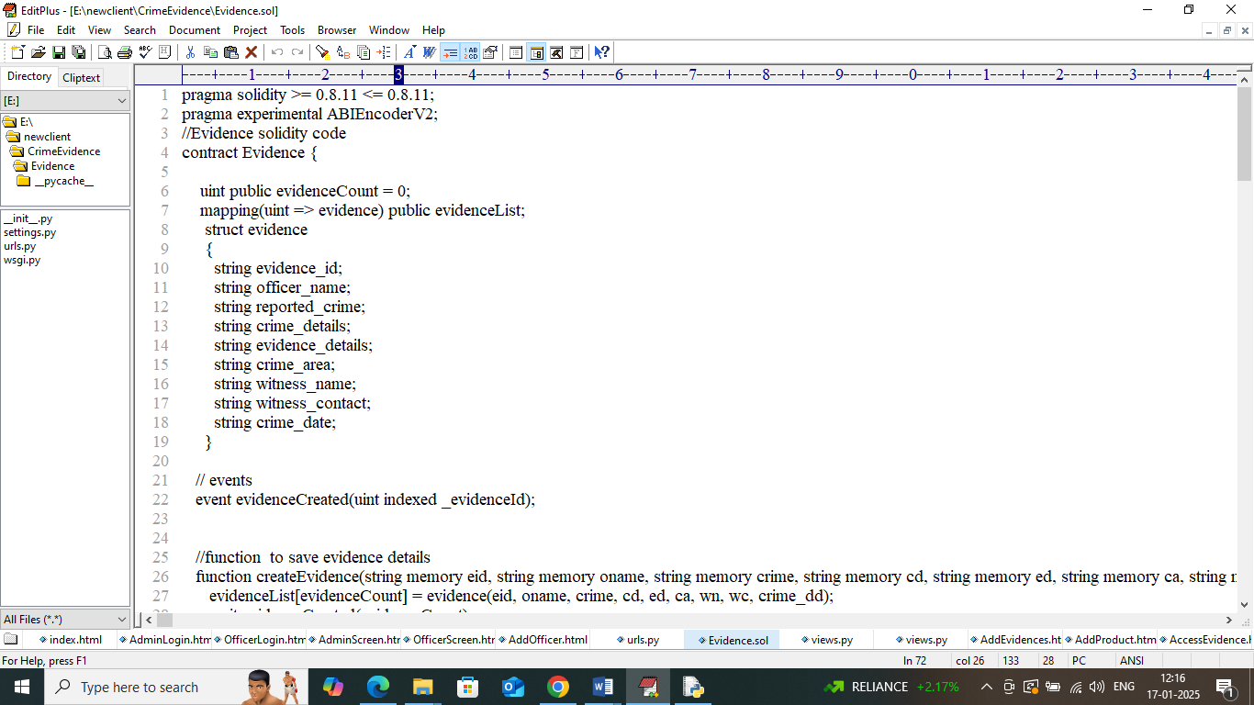

In above contract we have defined functions to manage evidence details and above contract need to deployed in Blockchain Ethereum using below steps

1. First go inside ‘hello-eth/node-modules/bin’ folder and then look and double click on ‘runBlockchain.bat’ file to get below page
2. 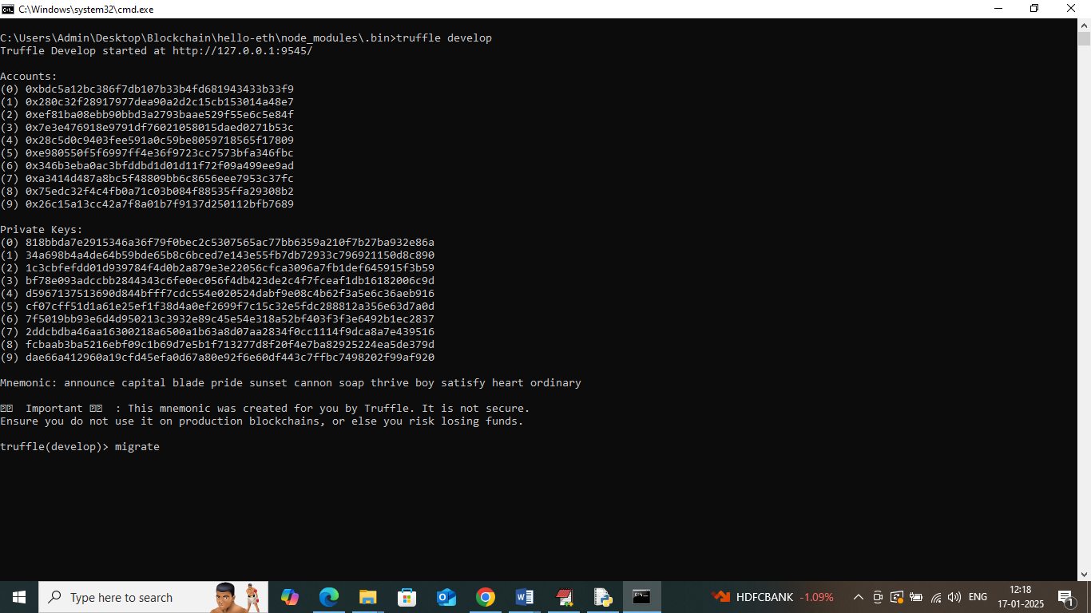
3. In above screen Ethereum started with default account and private keys and now type command as ‘migrate’ and then press enter key to deploy contract and get below page
4. 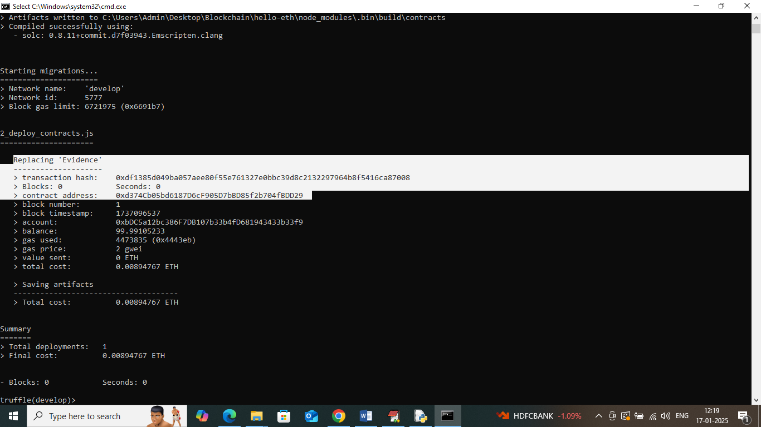
5. In above screen in white colour text can see “evidence” contract deployed and got contract address also and this address need to specify in python programming to call Blockchain contract functions to save and get data. in below screen showing python code calling contract using address
6. 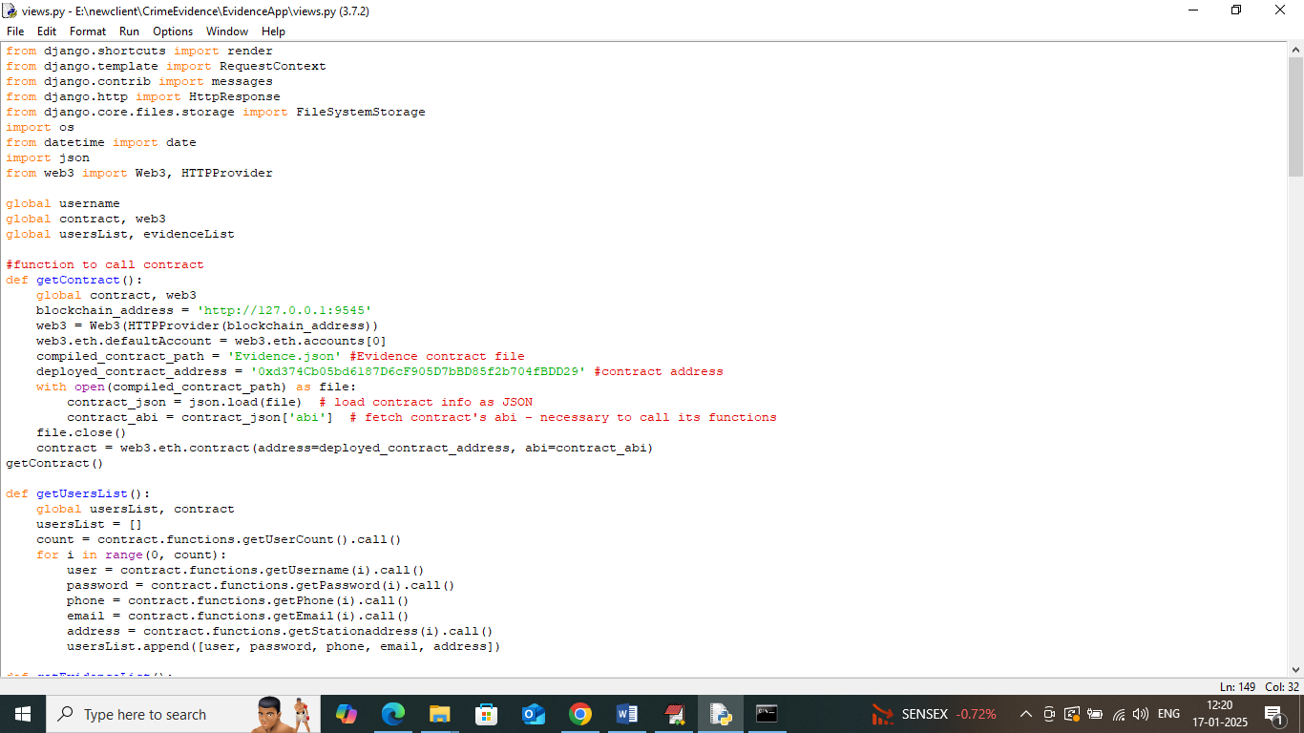
7. In above screen read red colour comments to know about contract calling using address. In above black screen we have deployed contract and running successfully and let it run till you execute code.

Modules Information

To implement this project we have designed following modules

1. Admin Login: police department admin can login to system using username and password as ‘admin and admin’.
2. Add Officer Details: after login admin will use this module to add officer and police station details to Blockchain. Admin will issue login details to all officers
3. View Officer: using this module admin can view list of available officers posted in different police station address.
4. View Evidence: admin can view list of evidences and crime added by different officers
5. Officer Login: any area officer can login to system using login details given by admin
6. Add New Evidences: using this module officer will record all crime and evidence details to Blockchain
7. Access Evidences: using this module officer can access crime and evidence details saved in Blockchain.

SCREEN SHOTS

To run project double click on ‘run.bat’ file to start python server and get below page

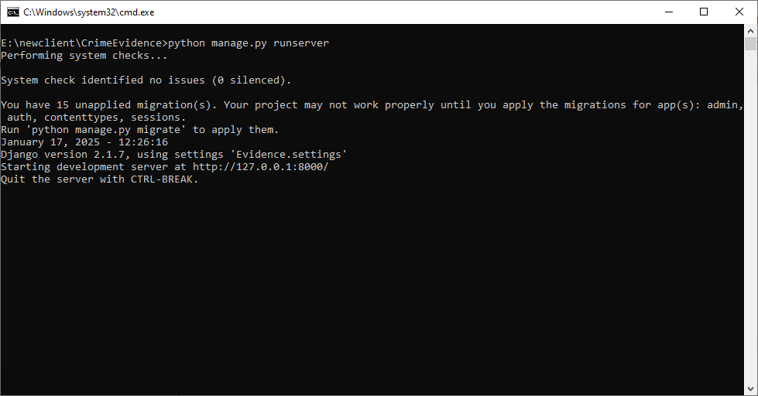

In above screen python server started and now open browser and enter URL as <http://127.0.0.1:8000/index.html> and then press enter key to get below page

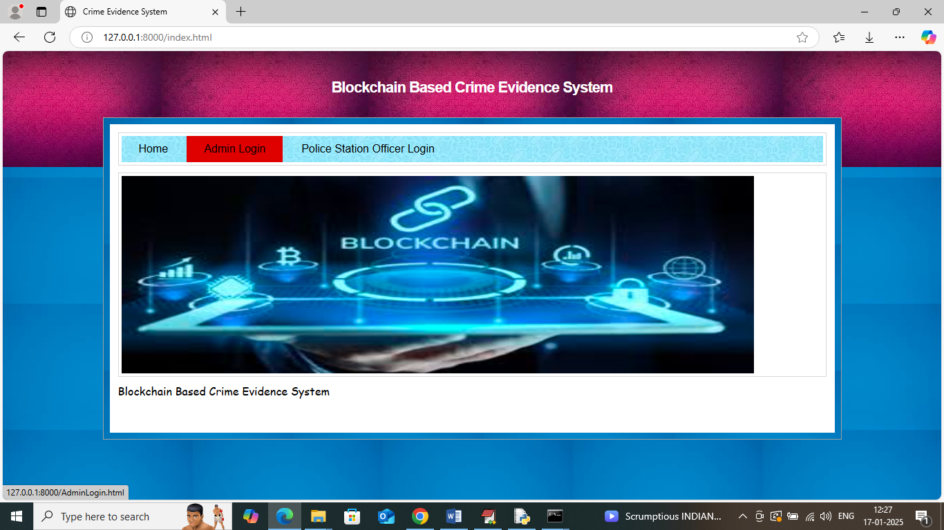

In above screen click on ‘Admin Login’ link to get below page

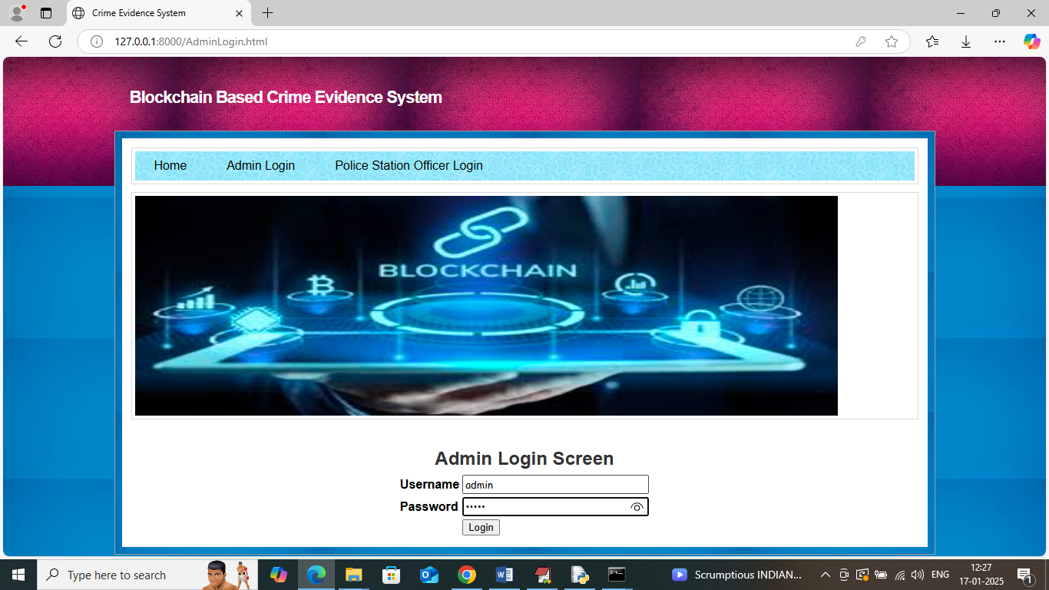

In above screen admin is login and after login will get below page

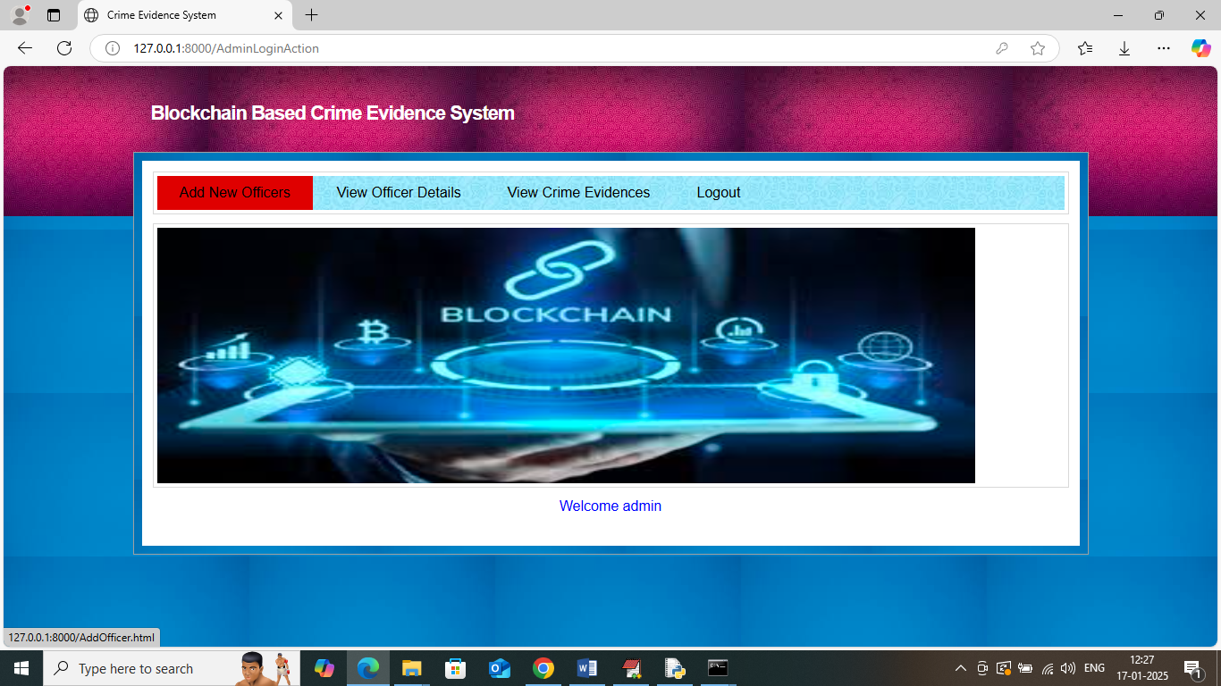

In above screen admin can click on ‘Add New Officer’ link to get below page

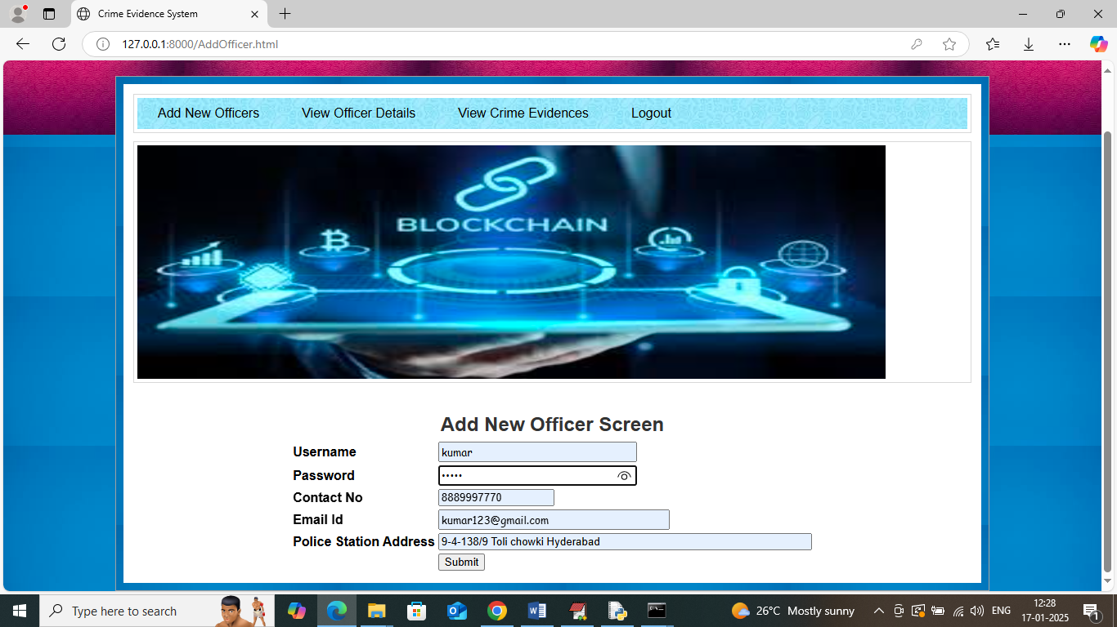

In above screen admin adding details of new officer and then press button to save data in Blockchain and then will get below page

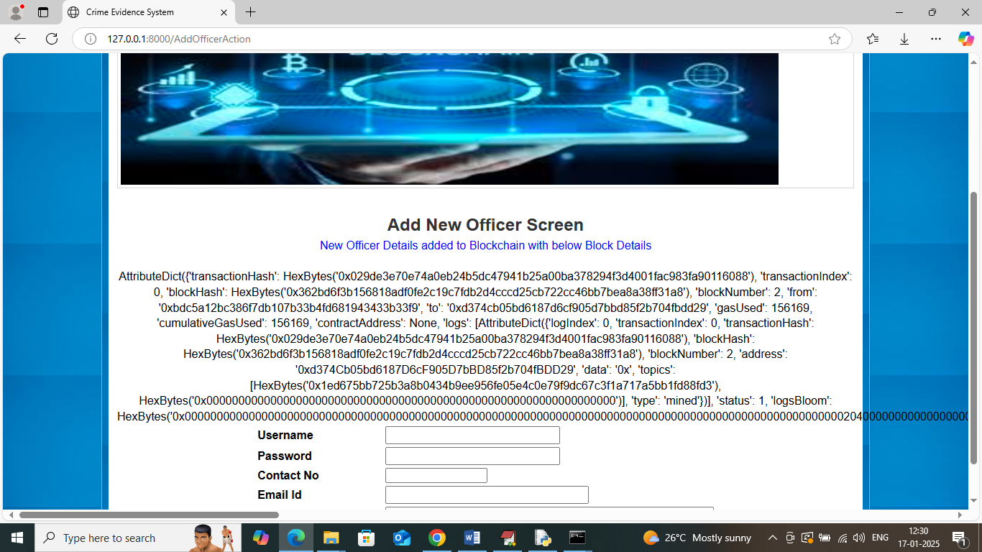

In above screen can see Officer Details added to Blockchain and then in Black colour text displaying all log details obtained from Blockchain which contains details like Block No, transaction no, transaction hash code and many other details. Now click on ‘View Officer’ link to view list of available officers

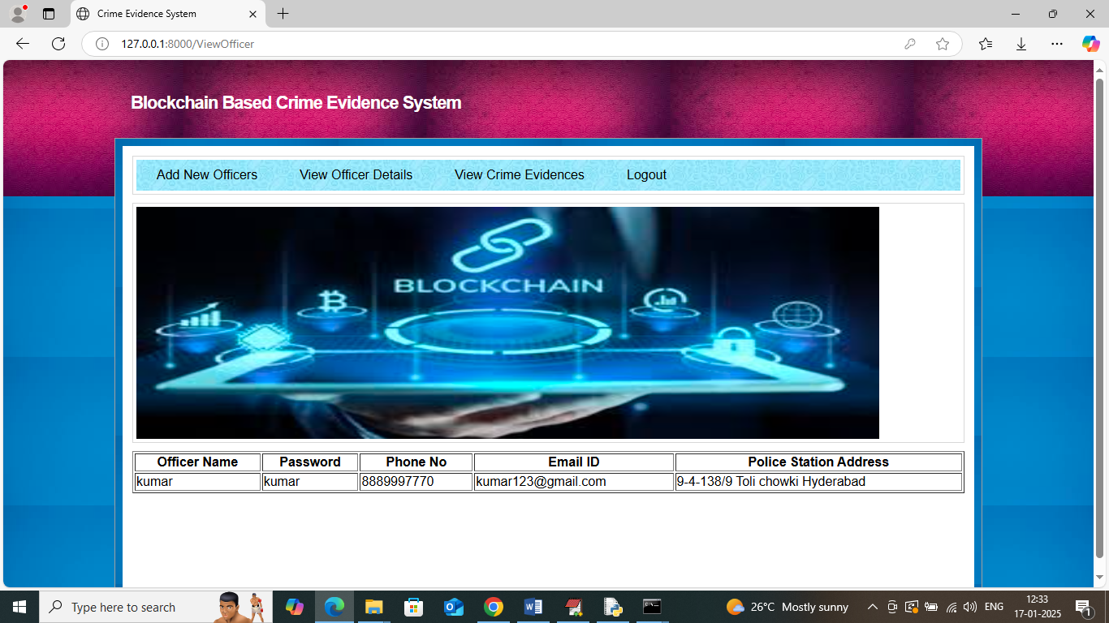

In above screen admin can view list of available officers and now logout and login as officer to add investigation details

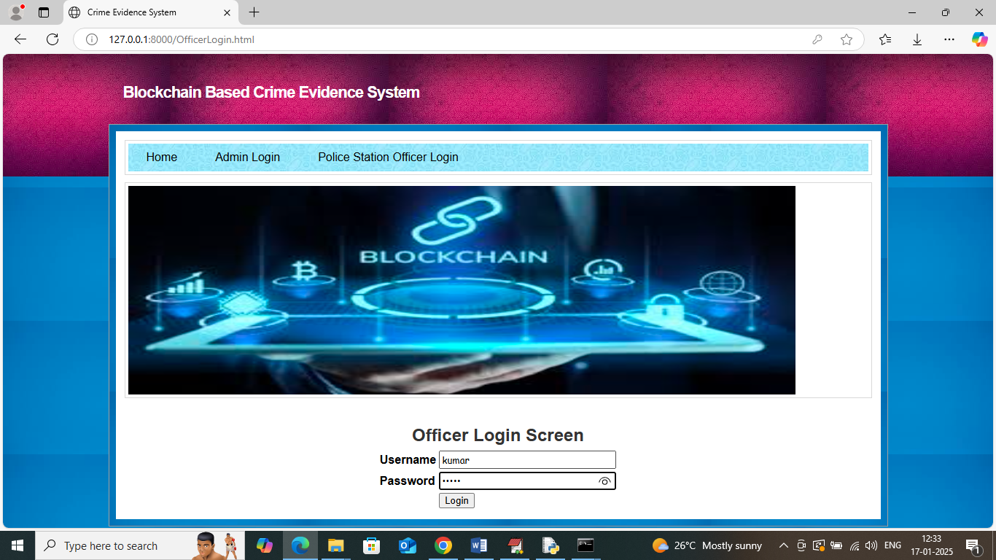

In above screen officer is login and after login will get below page

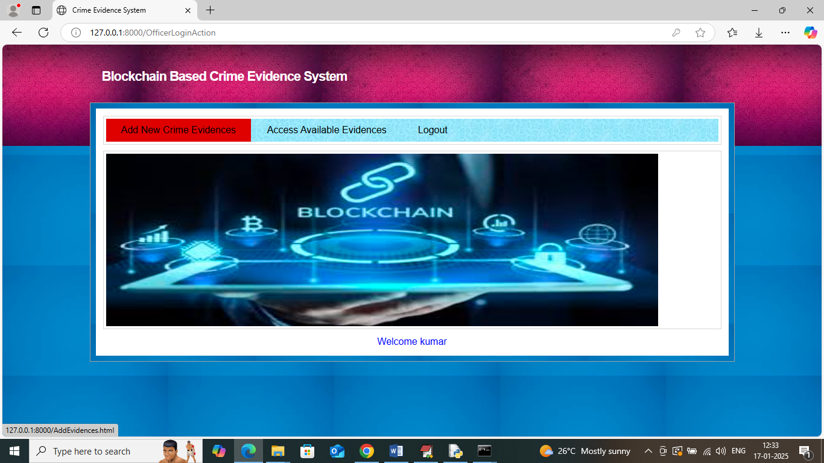

In above screen officer can click on ‘Add New Crime Evidence’ link to get below page

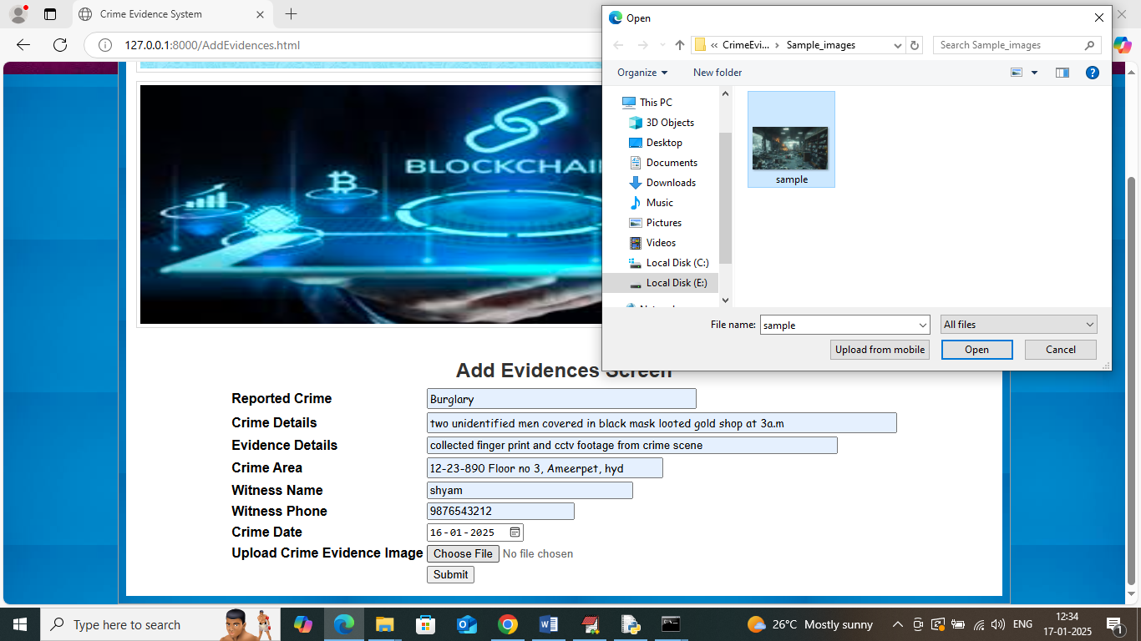

In above screen adding all crime and evidence details along with image and then press button to save data in Blockchain and then will get below page

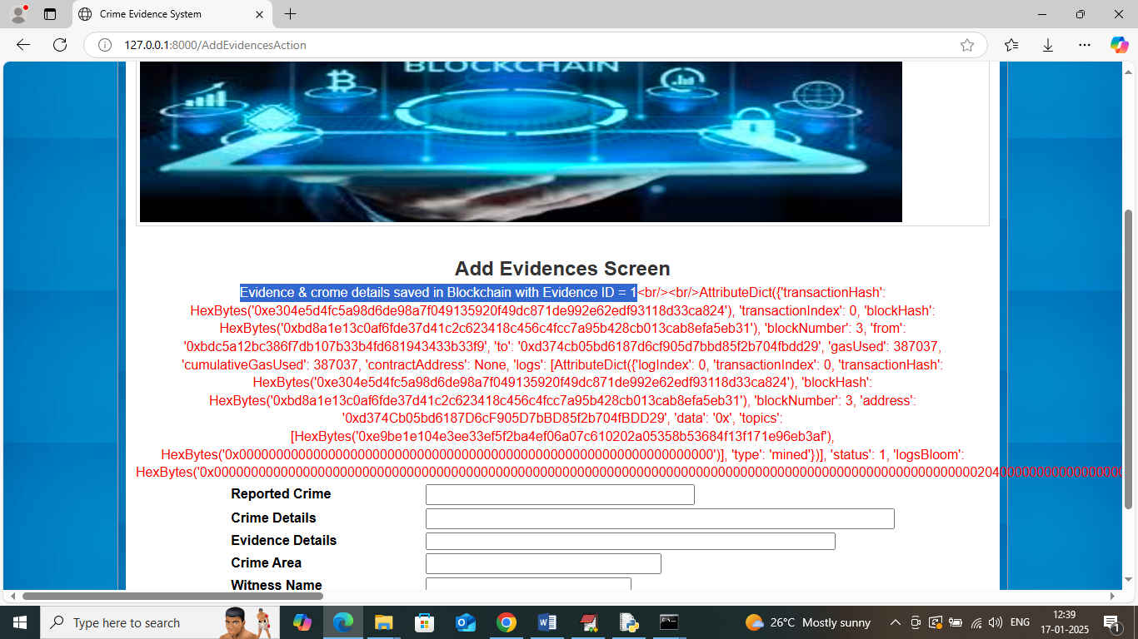

In above screen can see crime and evidence details added to Blockchain and can see details of log which contains block no and other information. Now click on ‘Access Evidence’ link to get below page

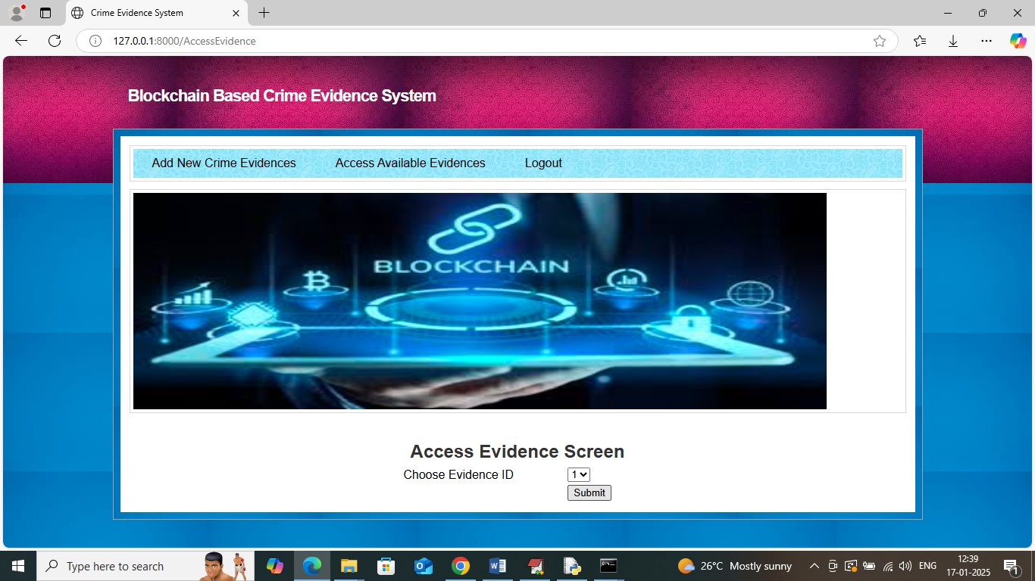

In above screen officer can select evidence Id and then press button to get all details from Blockchain

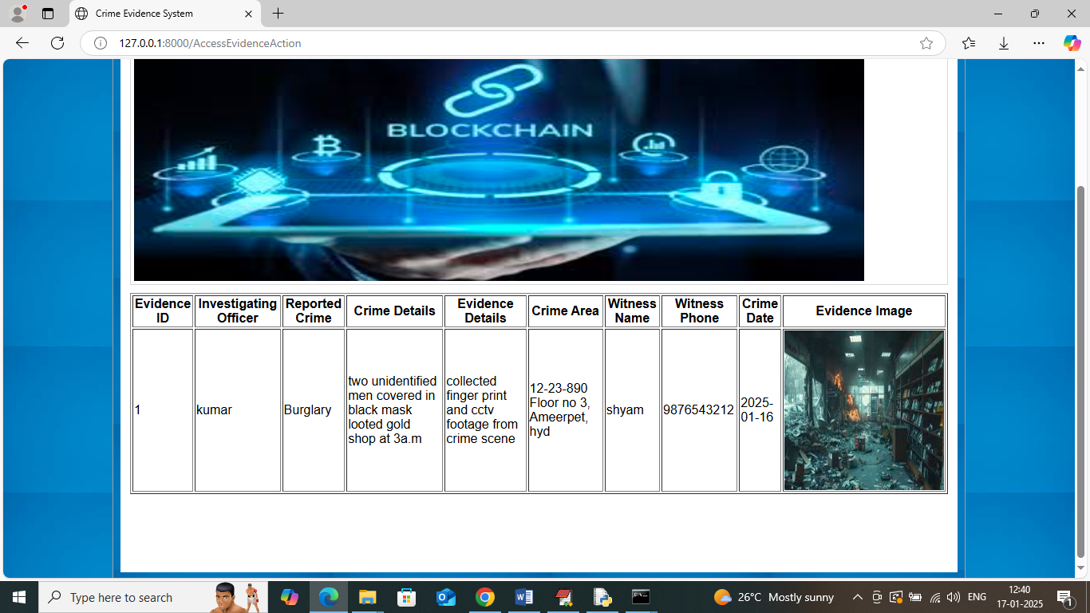

In above screen officer can view all evidence and crime details obtained from Blockchain.

Similarly by following above screens you can manage all crime and evidence details in Blockchain.

**Conclusion:**

The "Blockchain Based Crime Evidence System" successfully demonstrates how blockchain technology can be leveraged to secure, decentralize, and authenticate crime evidence records. Traditional centralized crime evidence systems are vulnerable to tampering, primarily due to unrestricted access by administrators and the lack of traceable audit trails. By using blockchain's immutable and transparent ledger, this system ensures that once evidence is recorded, it cannot be altered or deleted without detection.

Through smart contracts deployed on Ethereum and integrated with a user-friendly Python-based frontend, both administrators and officers can safely add, retrieve, and view evidence-related data. The system effectively captures transaction metadata such as block numbers and hash codes, enabling traceability and forensic accountability. This solution significantly enhances the reliability of digital crime evidence handling and fosters greater trust in legal proceedings.

**Future Work:**

While the current system lays a strong foundation, there are several directions for future enhancement:

1. **Integration with National Crime Databases**: Future iterations could interface with centralized national or interdepartmental crime databases to allow broader access and verification.
2. **Mobile Accessibility**: Implementing mobile apps for Android and iOS can help officers log evidence from the crime scene in real time, improving efficiency and timeliness.
3. **Multimedia Support Expansion**: Adding capabilities to securely store and retrieve audio/video evidence alongside images can broaden the scope of evidence types handled.
4. **AI for Evidence Analysis**: Integrating AI algorithms for image and document analysis can help in automatically classifying and tagging evidence.
5. **Role-Based Access Control (RBAC)**: Introducing more granular access levels and audit trails for different user roles (officers, supervisors, judiciary, etc.) to enhance data governance.
6. **Scalability and Network Optimization**: Testing and adapting the system to work on private or consortium blockchains can improve speed and scalability for larger datasets.
7. **Legal Compliance and Digital Signature Integration**: Incorporating digital signatures and aligning with legal standards for electronic evidence submission will increase court admissibility and legal compliance.

**References**

1. **Nakamoto, S. (2008)**  
   *Bitcoin: A Peer-to-Peer Electronic Cash System*  
   This is the original whitepaper that introduced blockchain technology and its decentralized, tamper-proof architecture.  
   Link
2. **Zheng, Z., Xie, S., Dai, H., Chen, X., & Wang, H. (2018)**  
   *An Overview of Blockchain Technology: Architecture, Consensus, and Future Trends*  
   In *2017 IEEE International Congress on Big Data (BigData Congress)*  
   DOI: 10.1109/BigDataCongress.2017.85  
   This paper provides a comprehensive overview of blockchain technology and its application in secure data storage.
3. **Christidis, K., & Devetsikiotis, M. (2016)**  
   *Blockchains and Smart Contracts for the Internet of Things*  
   *IEEE Access, 4*, 2292–2303.  
   DOI: 10.1109/ACCESS.2016.2566339  
   Supports the use of smart contracts (like Solidity) for managing data, such as crime evidence.
4. **Swan, M. (2015)**  
   *Blockchain: Blueprint for a New Economy*  
   O’Reilly Media.  
   This book outlines potential blockchain use cases beyond cryptocurrency, including law enforcement and data integrity.
5. **Yli-Huumo, J., Ko, D., Choi, S., Park, S., & Smolander, K. (2016)**  
   *Where is current research on Blockchain technology?—A systematic review*  
   *PLOS ONE, 11*(10), e0163477.  
   DOI: 10.1371/journal.pone.0163477
6. **Kumar, R., & Tripathi, R. (2021)**  
   *Secure Storage of Criminal Evidence Using Blockchain*  
   *International Journal of Computer Applications*, 183(3), 1–6.  
   This paper deals specifically with secure evidence handling using blockchain.
7. **Atlam, H. F., & Wills, G. B. (2019)**  
   *Technical Aspects of Blockchain and IoT*  
   In *Internet of Things (IoT): Systems and Applications* (pp. 1–41).  
   Springer. Discusses tamper-proof storage and validation mechanisms.
8. **Zyskind, G., Nathan, O., & Pentland, A. (2015)**  
   *Decentralizing privacy: Using blockchain to protect personal data*  
   In *2015 IEEE Security and Privacy Workshops*.  
   DOI: 10.1109/SPW.2015.27
9. **Solidity Documentation (2024)**  
   *Solidity — Smart Contract Language for Ethereum*  
   https://docs.soliditylang.org/  
   Provides guidance on writing smart contracts used in your system.
10. **Wood, G. (2014)**  
    *Ethereum: A Secure Decentralized Generalized Transaction Ledger*  
    Ethereum Project Yellow Paper.  
    Describes Ethereum’s design, which underlies smart contract deployment in your project.  
    Link